Date | Time | Event | Private Use for 12 | Shared Use Places | Notes
Sat 23rd Jan | 7.00pm | The Libertines | £999 | £99
Sun 24th Jan | 7.00pm | The Corrs | £1390 | £139
Fri 29th Jan | 7.00pm | TNA Wrestling | £999 | £99 | short stage*
Sat 30th Jan | 2.30pm | Strictly Come Dancing | £1290 | £129
Sat 30th Jan | 7.30pm | Strictly Come Dancing | £1290 | £129
Sun 31st Jan | 1.30pm | Strictly Come Dancing | £1290 | £129
Tue 2nd Feb | 7.00pm | Nitro Circus Live | £poa | n/a
Thu 4th Feb | 7.00pm | Jason Derulo | £1290 | £129 | short stage*
Sat 6th Feb | 7.00pm | Carnival of Madness | £999 | £99
Thu 11th Feb | 7.00pm | Tame Impala | £899 | £99 | short stage*
Fri 12th Feb | 7.00pm | All Time Low | £999 | £99
Sat 13th Feb | 7.00pm | Foals | £poa | £99
Sat 27th Feb | 5.00pm | Quigg v Frampton | £poa | n/a
Sat 5th Mar | 7.00pm | Wet Wet Wet | £poa | n/a | short stage*
Sat 12th Mar | 2.30pm | X Factor Live | £1290 | £129
Sat 12th Mar | 7.30pm | X Factor Live | £1290 | £129
Sat 19th Mar | 7.00pm | Ellie Goulding | £poa | £89
Thu 24th Mar | 7.00pm | Little Mix | £poa | n/a
Fri 25th Mar | 7.00pm | A-Ha | £1280 | £128 | short stage*
Tue 5th April | 7.00pm | Janet Jackson | £1990 | £199
Thu 7th April | 7.00pm | Little Mix | £1490 | £149
Fri 8th April | 7.00pm | Muse | £1590 | £159
Sat 9th April | 7.00pm | Muse | £1690 | £169
Sun 10th April | 7.00pm | Jeff Lynne’s ELO | £poa | n/a
Tue 12th April | 7.00pm | Macklemore & Ryan Lewis | £999 | £99
Sat 16th April | 7.00pm | The Vamps | £poa | n/a
Tue 19th April | 7.00pm | WWE Wrestlemania | £1490 | £89
Fri 22nd April | 7.00pm | 5 Seconds Of Summer | £poa | n/a
Sat 23rd April | 7.00pm | 5 Seconds Of Summer | £1290 | £139
Sun 1st May | 7.00pm | Harlem Globetrotters | £poa | £99 | short stage*
Thu 5th May | 7.00pm | Premier League Darts | £poa | n/a | short stage*
Fri 6th May | 7.00pm | Bryan Adams | £1990 | £225
Sun 8th May | 7.00pm | The Sessions (Beatles) | £1290 | £139
Fri 13th May | 7.00pm | James | £1790 | £189
Sat 14th May | 7.00pm | Il Divo | £1790 | £189 | short stage*
Sat 21st May | 7.00pm | Busted | £1490 | £159
Fri 3rd June | 7.00pm | Busted | £1490 | £159
Wed 15th June | 7.00pm | Barry Manilow | £3490 | £359
Tue 29th Nov | 7.00pm | The Cure | poa

prices are plus vat and subject to availability

*this event will be a different stage layout with a possible restricted view so an alternative suite will be used to guarantee a clear view

VIP Suite Package includes:-
- Officially Allocated Tickets included
- Private Use for 12 or Shared Use
- Premium location next to the stage
- VIP Parking
- VIP Fastrack Entrance
- En-Suite WC and Cloakroom
- Private Cash Bar
- Designated Suite Attendant
- Inclusive food options can be added
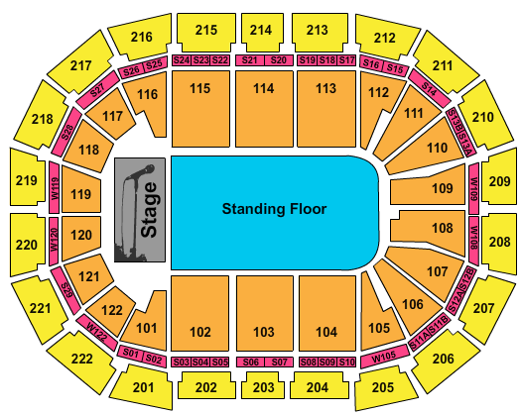
Premium Location above Block 102 (see plan above)

CONTACT US ON 0161 848 7955
OR EMAIL pippa@thehospitalitybroker.com

